Chapter 1

What is software?

* Computer programs and associated documentation. Generic or Customized.

What are the attributes of good software?

* Deliver the required functionality and performance to the user. Maintainable, dependable, and usable.

What are fundamental software engineering activities?

* Specification, Development, Validation, Evolution

What is the difference between software engineering and computer science?

* CS focuses on theory an fundamentals; SE concerned with practicalities of developing and delivering useful software.

What is the difference between software engineering and system engineering?

* System engineering is concerned with all aspects of computer – based systems development including hardware, software and process engineering. Software engineering is a more general process .

What are the key challenges facing software engineering?

* Coping with increasing diversity, demands for reduced delivery times and trustworthy software.

What are the costs of software engineering?

* 60% software costs and development costs, 40% testing costs. For customized, evolution often exceeds development costs.

What are the best software engineering techniques and methods?

* Different techniques are appropriate for different types of systems.

What differences has the web made to software engineering?

* The web has led to the development of software services and the possibility of developing highly distributed service-based systems. Web-based systems development has led to important advances in programing languages and software reuse.

Essential Attributes of Good Software:

1. Maintainability – Software should be able to evolve
2. Dependability and Security
3. Efficiency – Responsiveness, processing time, memory utilization, etc.
4. Acceptability – Must be compatible with various systems

Software engineering is a discipline that is concerned with all aspects of software production.

Engineering Discipline – using appropriate methods to solve problems involving organizational and financial constraints.

It is usually cheaper, in the long run, to use software engineering methods for software systems rather than just write the programs as if it was a personal programming project. For most systems, the majority of costs are the costs of changing the software after it has gone into use.

General Issues that affect most Software:

1. Heterogeneity – increasingly, systems are required to operate as distributed systems across networks that include different types of computer and mobile devices.
2. Business and social change – Need to be able to change existing software to rapidly develop new software.
3. Security and Trust

Application Types:

1. Stand-Alone Applications- they run on a local computer and include all necessary functionality and do not need to be connected to a network.
2. Interactive Transaction-Based – they execute on a remote computer and are accessed by users from their own PCs or terminals. Include web apps, such as e-commerce apps.
3. Embedded Control Systems – software control systems that control and manage hardware devices. More embedded systems than any other type of system.
4. Batch Processing Systems – business systems designed to process data in large batches.
5. Entertainment Systems – primarily for personal use to entertain
6. Modeling and Simulation – developed by scientists and engineers to model physical processes or situation, which may include many, separate, interacting objects.
7. Data Collection Systems – collect data from their environment using a set of sensors and send that data to other systems for processing
8. Systems of Systems – composed of a number of other software systems.

Software Engineering Fundamentals:

1. Systems should be developed using a managed and understood development process.
2. Dependability and performance are important for all types of systems
3. Understanding and managing the software requirements.
4. Reuse software where appropriate.

Software Engineering and the Web:

1. The Web is now a platform for running applications and increasingly popular than local
2. Allow application functionality to be accessed over the Web
3. Cloud computing where applications can run remotely on the “cloud”

Web Software Engineering:

1. Software reuse is the dominant approach for constructing web-based systems.
2. Should be developed and delivered incrementally.
3. User interfaces are constrained by the capabilities of the web browsers.
4. They are complex distributed systems but that carry the same fundamentals as other types

Software Engineering Ethics:

1. Involves wider responsibility than simply the application of technical skills
2. Must behave in an honest and ethically responsible way
3. Ethical behavior is more than upholding the law but following a set of principles that are morally correct.

Issues of Professional Responsibility:

1. Confidentiality
2. Competence – Should not knowingly accept work, which is beyond their competence.
3. Intellectual Property Rights – such as patents and copyrights.
4. Computer Misuse – game playing on employers machines or dissemination of viruses.

ACM/IEEE Code of Ethics:

1. Created by the professional societies in the US.
2. Members sign up for these organizations when they join.
3. Consists of 8 principles related to the behavior and decisions made by professional software engineers, including practitioners, educators, managers, supervisors, and policy makers, as well as trainees and students of the profession.
4. Eight principles – Public, Client, Product, Judgment, Management, Profession, Colleagues, Self

Ethical Dilemmas:

1. Disagreement in principle with the policies of senior management.
2. Employer acts in an unethical way, releasing a safety-critical system without finishing
3. Participation in the development of military weapons systems or nuclear systems

Case Studies:

1. Personal Insulin Pump – used by diabetics to maintain blood glucose control
2. A mental health case patient management system – used to maintain records for health issue
3. A wilderness weather station

Chapter 2

Software Processes: a structured set of activities required to develop a software system

1. Specification – defining what the system should do
2. Design and Implementation – defining the organization of the system
3. Validation – checking that it does what the customer wants
4. Evolution – changing the system in response to changing customer needs
5. A software process model is an abstract representation of a process. It presents a description of a process from some particular perspective.

Software Process Descriptions:

1. Activities such as specifying a data model, designing the UI, etc.
2. Products, which are the outcomes of a process activity
3. Roles, which reflect the responsibilities on the people involved in the process.
4. Pre and Post Conditions, statements that are true before and after a process

Plan-Driven and Agile Processes:

1. Plan-driven process is where all of the process activities are planned in advance and progress is measured against this plan
2. In agile processing, planning is incremental and it is easier to change the process to reflect changing customer requirements.
3. In practice, most practical processes include elements of both plan-driven and agile approaches.
4. THERE ARE NO WRONG OR RIGHT SOFTWARE PROCESSES

Software Process Models:

1. Waterfall Model – **plan-driven model**, separate and distinct phases of specification and development.
2. Incremental Development – specification, development from existing components. **Plan-driven or agile.**
3. Reuse-oriented software engineering – system is assembled from existing components. **Plan-driven or agile**

Waterfall Model:

**2.1.Waterfall-model.eps**

Waterfall Model Phases:

1. Requirements analysis and definition
2. System and software design
3. Implementation and unit testing
4. Integration and system testing
5. Operation and maintenance

* The main fallback of the waterfall model is the difficulty of accommodating change after the process is underway.

Waterfall Model Problems:

1. Inflexible partitioning of the project into distinct stages makes it difficult to respond to changing customer requirements. Therefore, this model is only appropriate when the requirements are well understood and changes will be fairly limited.
2. Few business systems have stable requirements.
3. Mostly used for large system engineering projects where a system is developed at several sites.
4. The plan-driven nature of the waterfall model helps coordinate the work.

Incremental Development:

2.2 Incremental-dev.eps

Incremental Development Benefits:

1. The cost of accommodating changing customer requirements is reduced.
2. Easier to get customer feedback on the work that has been done
3. More rapid delivery and deployment of useful software to the customer is possible
4. The process is not visible
5. System structure tends to degrade as new increments are added.

Reuse-Oriented Software Engineering: based on systematic reuse where systems are integrated from existing components or COTS(Commercial-off-the-shelf) systems.

Process Stages:

1. Component Analysis
2. Requirements Modification
3. System design with reuse
4. Development and Integration
5. -Reuse is now the standard approach for buildin g many types of business systems

2.3 Reuse_based_process.eps

Types of Software Components:

1. Web Services that are developed according to service standards
2. Collections of objects that are developed as a package top be integrated with framework.
3. Stand-alone software systems(COTS) that are configured for a particular environment.

Process Activities:

* Real software processes are inter-leaved sequences of technical, collaborative and managerial activities with the overall goal of specifying, designing, implementing and testing a software system.
* The 4 basic process activities of specification, development, validation and evolution are organized differently in different development processes. In the waterfall model, they are organized in sequence, whereas in incremental development they are inter-leaved.

Software Specification:

* The process of establishing what services are required and the constraints on the systems operation and development.

Requirements Engineering Process:

1. Feasibility Study – is it technically and financially feasible to build.
2. Requirements elicitation and Analysis – what to expect
3. Requirements Specification – defining the requirements in detail
4. Validation – checking the validity of the requirements

-The requirements engineering process:

2.4 RE-process.eps

Software Design and Implementation:

1. The process of converting the system specification into an executable system.
2. Software Design – Realizes the specification
3. Implementation – translate this structure into an executable program
4. The activities of design and implementation are closely related and may be inter-leaved.

A general model of the design process:

2.5 Design-process.eps

Design Activities:

1. Architectural – identify the overall structure of the system, the principle components, their relationships and how they are distributed.
2. Interface – where you define the interfaces between system components.
3. Component – take each system component and design how it will operate.
4. Database – design the system data structures and how to be represented in database.

Software Validation:

1. Verification and Validation (V&V) is intended to show that a system conforms to its specification and meets the requirements.
2. Involves checking and review processes and system testing
3. System testing involves executing the system with real test cases to be process by the system
4. **Testing is the most commonly used V&V activity**

**Stages of Testing:**

2.6 Testing-process.eps

Testing Stages:

1. Development of component testing – individual components are tested independently.
2. System Testing – testing the system as a whole
3. Acceptance Testing – testing with customer data to make sure it meets the needs

Testing Phases in a Plan-Driven Software Process:

2.7 Testing-phases.eps

Software Evolution:

1. Software is inherently flexible and can change.
2. As requirements change through changing business circumstances, the software must also.
3. Fewer and fewer systems are completely new.

System Evolution Model:

2.8 System evolution.eps

Reducing the costs of rework:

1. Change avoidance - where the software process includes activities that can anticipate possible changes before significant work is required.
2. Change Tolerance – the process is designed so that changes can be accommodated at relatively low cost.

Software Prototyping:

1. A prototype is an initial version of a system used to demonstrate concepts and try out design
2. A prototype can be used in the requirements engineering process to help with the requirements, elicitation and validation; design processes to explore options and develop UI design; testing process to run back-to-back tests.

Benefits of Prototyping:

1. Improved system usability
2. A closer match to users real needs
3. Improved design quality
4. Improved maintainability
5. Reduced development effort

The Process of Prototype Development:

2.9 PrototypeProcess.eps

Prototype Development:

1. May be based on rapid prototyping languages or tools
2. May involve leaving out functionality – should focus on areas of the product that are not well understood; error checking and recovery may not be included in the prototype; focus on functional rather than non-functional requirements such reliability and security.

Throw-away Prototypes:

1. Prototypes should be discarded after development as they are no good for production
2. It may be impossible to tune the system to meet non-functional requirements; prototypes are normally undocumented; prototype structure is usually degraded through rapid change; the prototype probably will not meet normal organizational quality standards.

Incremental Delivery:

* Rather than deliver the system as a single delivery, the development and delivery is broken down into increments with each part delivering a part of the required functionality.
* User requirements are prioritized and the highest priority is included early.
* Once the development of an increment is started, the requirements are frozen through requirements for later increments can continue to evolve.

Incremental development:

* + Develop the system in increments and evaluate each increment before proceeding to the development of the next increment;
  + Normal approach used in agile methods;
  + Evaluation done by user/customer proxy.

Incremental delivery:

* + Deploy an increment for use by end-users;
  + More realistic evaluation about practical use of software;
  + Difficult to implement for replacement systems as increments have less functionality than the system being replaced.

Incremental Delivery Model:

2.10 Incremental-delivery.eps

Incremental Delivery Advantages:

1. Customer value can be delivered with each increment so system functionality is available earlier.
2. Early increments act as a prototype to help elicit requirements for later increments.
3. Lower risk of overall project failure.
4. The highest priority system services tend to receive the most testing.

Incremental Delivery Problems:

1. Most systems require a set of basic facilities that are used by different parts of the system.
   1. As requirements are not defined in detail until an increment is to be implemented, it can be hard to identify common facilities that are needed by all increments.
2. The essence of iterative processes is that the specification is developed in conjunction with the software.
   1. However, this conflicts with the procurement model of many organizations, where the complete system specification is part of the system development contract.

Boehm’s Spiral Model:

1. Process is represented as a spiral rather than as a sequence of activities with backtracking.
2. Each loop in the spiral represents a phase in the process.
3. No fixed phases such as specification or design - loops in the spiral are chosen depending on what is required.
4. Risks are explicitly assessed and resolved throughout the process.

2.11 Spiral-model.eps

Spiral Model Sectors:

1. Objective setting
   1. Specific objectives for the phase are identified.
2. Risk assessment and reduction
   1. Risks are assessed and activities put in place to reduce the key risks.
3. Development and validation
   1. A development model for the system is chosen which can be any of the generic models.
4. Planning
   1. The project is reviewed and the next phase of the spiral is planned.

Spiral Model Usage:

1. Spiral model has been very influential in helping people think about iteration in software processes and introducing the risk-driven approach to development.
2. In practice, however, the model is rarely used as published for practical software development.

The Rational Unified Process:

1. A modern generic process derived from the work on the UML and associated process.
2. Brings together aspects of the 3 generic process models discussed previously.
3. Normally described from 3 perspectives
   1. A dynamic perspective that shows phases over time;
   2. A static perspective that shows process activities;
   3. A practive perspective that suggests good practice.

Phases in the Rational Unified Process:

2.12 RUP phases.eps

RUP Phases:

1. Inception
   1. Establish the business case for the system.
2. Elaboration
   1. Develop an understanding of the problem domain and the system architecture.
3. Construction
   1. System design, programming and testing.
4. Transition
   1. Deploy the system in its operating environment.

RUP Iteration:

1. In-phase iteration
   1. Each phase is iterative with results developed incrementally.
2. Cross-phase iteration
   1. As shown by the loop in the RUP model, the whole set of phases may be enacted incrementally.

Static Workflows in the Rational Unified Process:

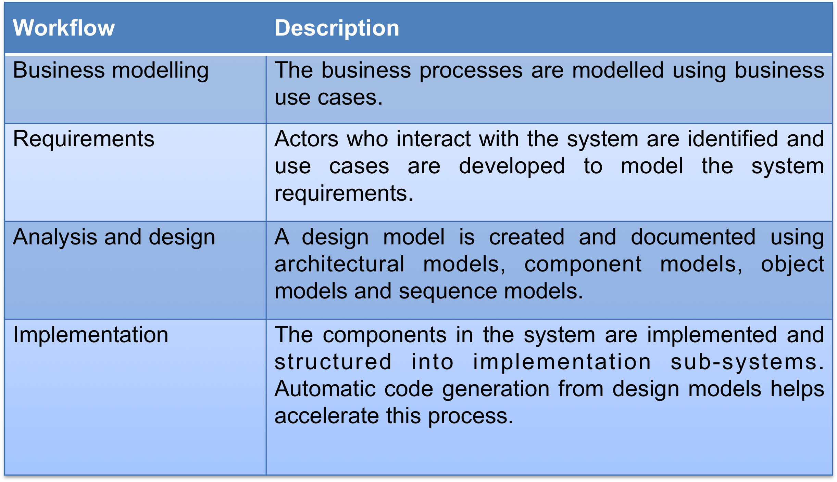

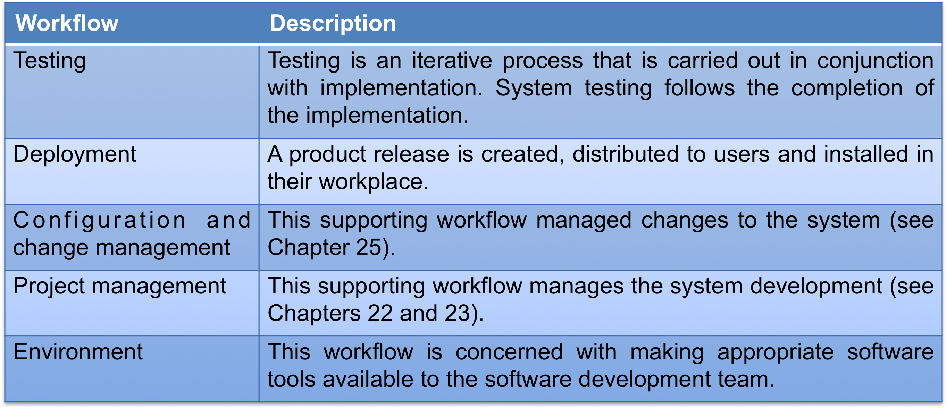

RUP Good Practice:

1. Develop software iteratively
   1. Plan increments based on customer priorities and deliver highest priority increments first.
2. Manage requirements
   1. Explicitly document customer requirements and keep track of changes to these requirements.
3. Use component-based architectures

a. Organize the system architecture as a set of reusable components.

1. Visually model software

a. Use graphical UML models to present static and dynamic views of the software.

1. Verify software quality

a. Ensure that the software meet’s organizational quality standards.

1. Control changes to software

a. Manage software changes using a change management system and configuration management tools.

Key Points:

1. Processes should include activities to cope with change. This may involve a prototyping phase that helps avoid poor decisions on requirements and design.
2. Processes may be structured for iterative development and delivery so that changes may be made without disrupting the system as a whole.
3. The Rational Unified Process is a modern generic process model that is organized into phases (inception, elaboration, construction and transition) but separates activities (requirements, analysis and design, etc.) from these phases.

Chapter 3:

Rapid Software Development:

1. Rapid development and delivery is now often the most important requirement for software systems
   1. Businesses operate in a fast –changing requirement and it is practically impossible to produce a set of stable software requirements
   2. Software has to evolve quickly to reflect changing business needs.
2. Rapid software development
   1. Specification, design and implementation are inter-leaved
   2. System is developed as a series of versions with stakeholders involved in version evaluation
   3. User interfaces are often developed using an IDE and graphical toolset.

Agile Methods:

1. Dissatisfaction with the overheads involved in software design methods of the 1980s and 1990s led to the creation of agile methods. These methods:
   1. Focus on the code rather than the design
   2. Are based on an iterative approach to software development
   3. Are intended to deliver working software quickly and evolve this quickly to meet changing requirements.
2. The aim of agile methods is to reduce overheads in the software process (e.g. by limiting documentation) and to be able to respond quickly to changing requirements without excessive rework.

Agile Manifesto:

1. *We are uncovering better ways of developing  software by doing it and helping others do it.  Through this work we have come to value:*
   1. *Individuals and interactions over processes and tools  
      Working software over comprehensive documentation   
      Customer collaboration over contract negotiation   
      Responding to change over following a plan*
2. *That is, while there is value in the items on  the right, we value the items on the left more.*

The principles of Agile Methods:

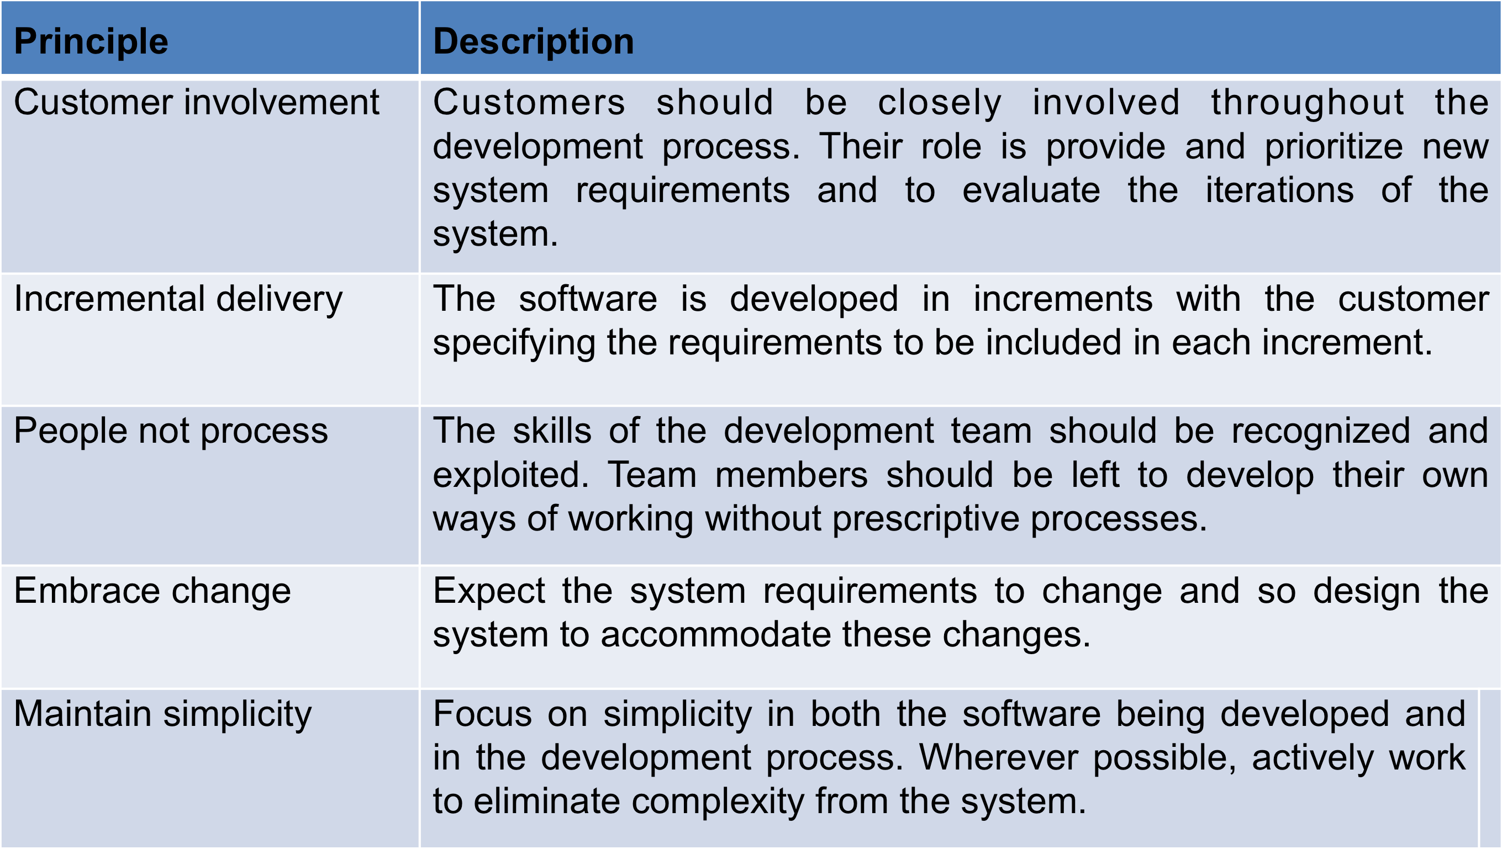

Agile Method Applicability:

1. Product development where a software company is developing a small or medium-sized product for sale.
2. Custom system development within an organization, where there is a clear commitment from the customer to become involved in the development process and where there are not a lot of external rules and regulations that affect the software.
3. Because of their focus on small, tightly-integrated teams, there are problems in scaling agile methods to large systems.

Problems with Agile Methods:

1. It can be difficult to keep the interest of customers who are involved in the process.
2. Team members may be unsuited to the intense involvement that characterizes agile methods.
3. Prioritizing changes can be difficult where there are multiple stakeholders.
4. Maintaining simplicity requires extra work.
5. Contracts may be a problem as with other approaches to iterative development.

Agile Methods and Software Maintenance:

1. Most organizations spend more on maintaining existing software than they do on new software development. So, if agile methods are to be successful, they have to support maintenance as well as original development.
2. Two key issues:
   1. Are systems that are developed using an agile approach maintainable, given the emphasis in the development process of minimizing formal documentation?
   2. Can agile methods be used effectively for evolving a system in response to customer change requests?
3. Problems may arise if original development team cannot be maintained.

Plan-driven and Agile Development:

1. Plan-driven development
   1. A plan-driven approach to software engineering is based around separate development stages with the outputs to be produced at each of these stages planned in advance.
   2. Not necessarily waterfall model – plan-driven, incremental development is possible
   3. Iteration occurs within activities.
2. Agile development
   1. Specification, design, implementation and testing are inter-leaved and the outputs from the development process are decided through a process of negotiation during the software development process.

Plan-driven and Agile Specification:

3.2 PlanBasedAgile.eps

Technical Human, Organizational Issues:

1. Most projects include elements of plan-driven and agile processes. Deciding on the balance depends on:
   1. Is it important to have a very detailed specification and design before moving to implementation? If so, you probably need to use a plan-driven approach.
   2. Is an incremental delivery strategy, where you deliver the software to customers and get rapid feedback from them, realistic? If so, consider using agile methods.
   3. How large is the system that is being developed? Agile methods are most effective when the system can be developed with a small co-located team who can communicate informally. This may not be possible for large systems that require larger development teams so a plan-driven approach may have to be used.
   4. What type of system is being developed?
      1. Plan-driven approaches may be required for systems that require a lot of analysis before implementation (e.g. real-time system with complex timing requirements).
   5. What is the expected system lifetime?
      1. Long-lifetime systems may require more design documentation to communicate the original intentions of the system developers to the support team.
   6. What technologies are available to support system development?
      1. Agile methods rely on good tools to keep track of an evolving design
   7. How is the development team organized?
      1. If the development team is distributed or if part of the development is being outsourced, then you may need to develop design documents to communicate across the development teams.
   8. Are there cultural or organizational issues that may affect the system development?
      1. Traditional engineering organizations have a culture of plan-based development, as this is the norm in engineering.
   9. How good are the designers and programmers in the development team?
      1. It is sometimes argued that agile methods require higher skill levels than plan-based approaches in which programmers simply translate a detailed design into code
   10. Is the system subject to external regulation?
       1. If a system has to be approved by an external regulator (e.g. the FAA approve software that is critical to the operation of an aircraft) then you will probably be required to produce detailed documentation as part of the system safety case.

Extreme Programming:

1. Perhaps the best-known and most widely used agile method.
2. Extreme Programming (XP) takes an ‘extreme’ approach to iterative development.
   1. New versions may be built several times per day;
   2. Increments are delivered to customers every 2 weeks;
   3. All tests must be run for every build and the build is only accepted if tests run successfully.

The Extreme Programming Release Cycle:

3.3-XP-ReleaseCycle.eps

Extreme Programming Practices: 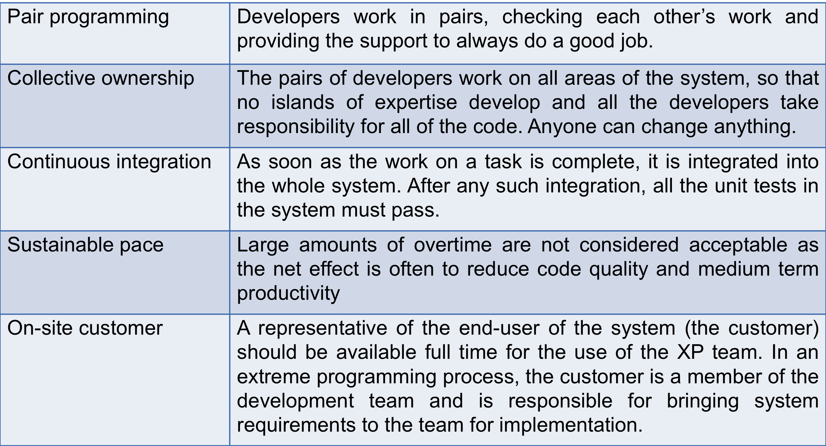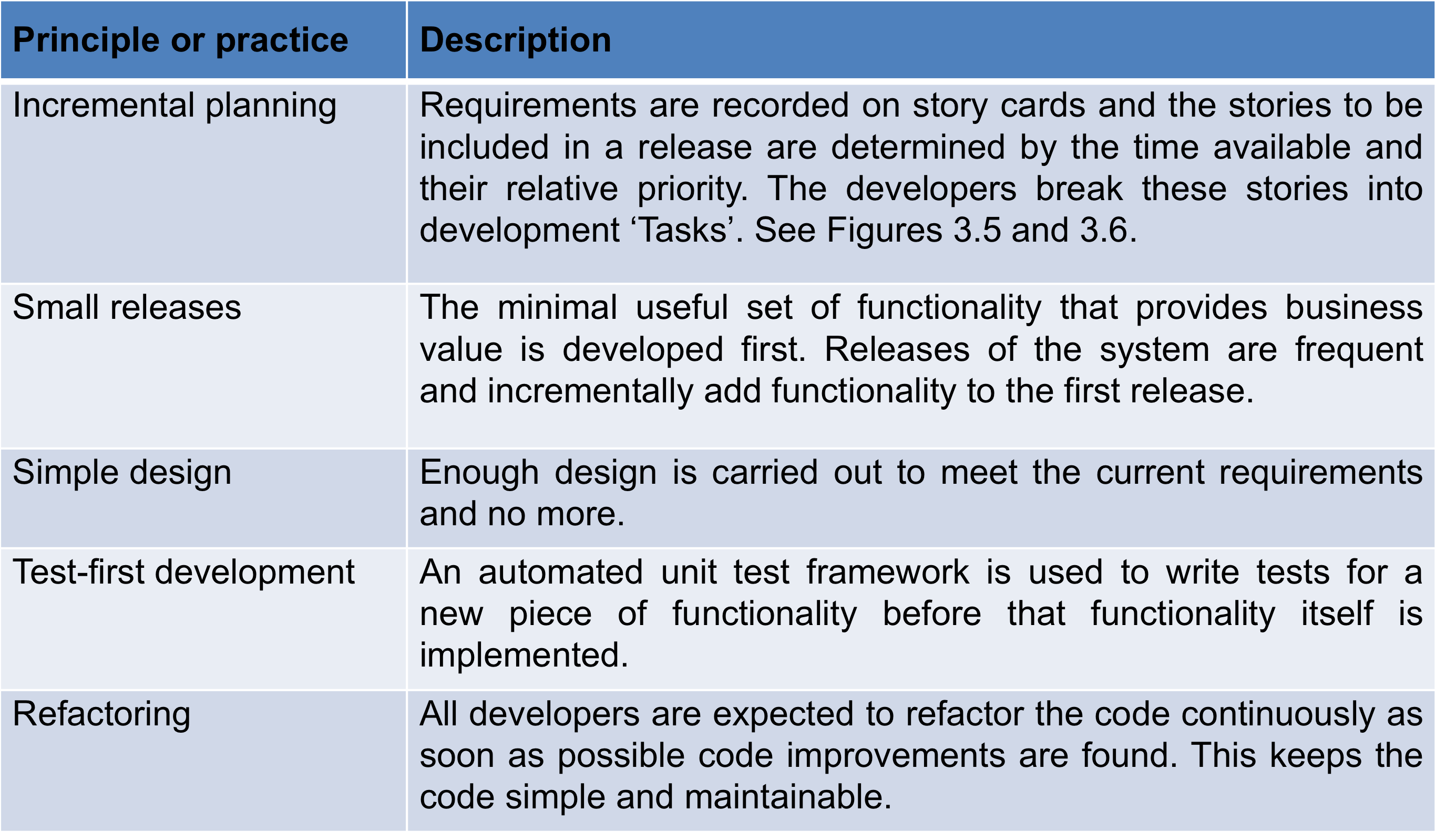

Requirements Scenarios:

1. In XP, a customer or user is part of the XP team and is responsible for making decisions on requirements.
2. User requirements are expressed as scenarios or user stories.
3. These are written on cards and the development team break them down into implementation tasks. These tasks are the basis of schedule and cost estimates.
4. The customer chooses the stories for inclusion in the next release based on their priorities and the schedule estimates.

XP and Change:

1. Conventional wisdom in software engineering is to design for change. It is worth spending time and effort anticipating changes as this reduces costs later in the life cycle.
2. XP, however, maintains that this is not worthwhile as changes cannot be reliably anticipated.
3. Rather, it proposes constant code improvement (refactoring) to make changes easier when they have to be implemented.

Refactoring:

1. Programming team look for possible software improvements and make these improvements even where there is no immediate need for them.
2. This improves the understandability of the software and so reduces the need for documentation.
3. Changes are easier to make because the code is well-structured and clear.
4. However, some changes requires architecture refactoring and this is much more expensive.

Key Points:

1. Agile methods are incremental development methods that focus on rapid development, frequent releases of the software, reducing process overheads and producing high-quality code. They involve the customer directly in the development process.
2. The decision on whether to use an agile or a plan-driven approach to development should depend on the type of software being developed, the capabilities of the development team and the culture of the company developing the system.
3. Extreme programming is a well-known agile method that integrates a range of good programming practices such as frequent releases of the software, continuous software improvement and customer participation in the development team.

Testing in XP:

1. Testing is central to XP and XP has developed an approach where the program is tested after every change has been made.
2. XP testing features:
   1. Test-first development.
   2. Incremental test development from scenarios.
   3. User involvement in test development and validation.
   4. Automated test harnesses are used to run all component tests each time that a new release is built.

First Test Development:

1. Writing tests before code clarifies the requirements to be implemented.
2. Tests are written as programs rather than data so that they can be executed automatically. The test includes a check that it has executed correctly.
   1. Usually relies on a testing framework such as Junit.
3. All previous and new tests are run automatically when new functionality is added, thus checking that the new functionality has not introduced errors.

Customer Involvement:

1. The role of the customer in the testing process is to help develop acceptance tests for the stories that are to be implemented in the next release of the system.
2. The customer who is part of the team writes tests as development proceeds. All new code is therefore validated to ensure that it is what the customer needs.
3. However, people adopting the customer role have limited time available and so cannot work full-time with the development team. They may feel that providing the requirements was enough of a contribution and so may be reluctant to get involved in the testing process.

Test Automation:

1. Test automation means that tests are written as executable components before the task is implemented
   1. These testing components should be stand-alone, should simulate the submission of input to be tested and should check that the result meets the output specification. An automated test framework (e.g. Junit) is a system that makes it easy to write executable tests and submit a set of tests for execution.
2. As testing is automated, there is always a set of tests that can be quickly and easily executed
   1. Whenever any functionality is added to the system, the tests can be run and problems that the new code has introduced can be caught immediately.

XP Testing Difficulties:

1. Programmers prefer programming to testing and sometimes they take short cuts when writing tests. For example, they may write incomplete tests that do not check for all possible exceptions that may occur.
2. Some tests can be very difficult to write incrementally. For example, in a complex user interface, it is often difficult to write unit tests for the code that implements the ‘display logic’ and workflow between screens.
3. It difficult to judge the completeness of a set of tests. Although you may have a lot of system tests, your test set may not provide complete coverage.

Pair Programming:

1. In XP, programmers work in pairs, sitting together to develop code.
2. This helps develop common ownership of code and spreads knowledge across the team.
3. It serves as an informal review process as each line of code is looked at by more than 1 person.
4. It encourages refactoring as the whole team can benefit from this.
5. Measurements suggest that development productivity with pair programming is similar to that of two people working independently.
6. In pair programming, programmers sit together at the same workstation to develop the software.
7. Pairs are created dynamically so that all team members work with each other during the development process.
8. The sharing of knowledge that happens during pair programming is very important as it reduces the overall risks to a project when team members leave.
9. Pair programming is not necessarily inefficient and there is evidence that a pair working together is more efficient than 2 programmers working separately.

Advantages in Pair Programming:

1. It supports the idea of collective ownership and responsibility for the system.
   1. Individuals are not held responsible for problems with the code. Instead, the team has collective responsibility for resolving these problems.
2. It acts as an informal review process because each line of code is looked at by at least two people.
3. It helps support refactoring, which is a process of software improvement.
   1. Where pair programming and collective ownership are used, others benefit immediately from the refactoring so they are likely to support the process.

Agile Project Management:

1. The principal responsibility of software project managers is to manage the project so that the software is delivered on time and within the planned budget for the project.
2. The standard approach to project management is plan-driven. Managers draw up a plan for the project showing what should be delivered, when it should be delivered and who will work on the development of the project deliverables.
3. Agile project management requires a different approach, which is adapted to incremental development and the particular strengths of agile methods.

SCRUM:

1. The Scrum approach is a general agile method but its focus is on managing iterative development rather than specific agile practices.
2. There are three phases in Scrum.
   1. The initial phase is an outline planning phase where you establish the general objectives for the project and design the software architecture.
   2. This is followed by a series of sprint cycles, where each cycle develops an increment of the system.
   3. The project closure phase wraps up the project, completes required documentation such as system help frames and user manuals and assesses the lessons learned from the project.

The Scrum Process:

3.8 ScrumProcess.eps

The Sprint Cycle:

1. Sprints are fixed length, normally 2–4 weeks. They correspond to the development of a release of the system in XP.
2. The starting point for planning is the product backlog, which is the list of work to be done on the project.
3. The selection phase involves all of the project team who work with the customer to select the features and functionality to be developed during the sprint.
4. Once these are agreed, the team organize themselves to develop the software. During this stage the team is isolated from the customer and the organization, with all communications channelled through the so-called ‘Scrum master’.
5. The role of the Scrum master is to protect the development team from external distractions.
6. At the end of the sprint, the work done is reviewed and presented to stakeholders. The next sprint cycle then begins.

Teamwork in Scrum:

1. The ‘Scrum master’ is a facilitator who arranges daily meetings, tracks the backlog of work to be done, records decisions, measures progress against the backlog and communicates with customers and management outside of the team.
2. The whole team attends short daily meetings where all team members share information, describe their progress since the last meeting, problems that have arisen and what is planned for the following day.
   1. This means that everyone on the team knows what is going on and, if problems arise, can re-plan short-term work to cope with them.

Scrum Benefits:

1. The product is broken down into a set of manageable and understandable chunks.
2. Unstable requirements do not hold up progress.
3. The whole team have visibility of everything and consequently team communication is improved.
4. Customers see on-time delivery of increments and gain feedback on how the product works.
5. Trust between customers and developers is established and a positive culture is created in which everyone expects the project to succeed.

Scaling Agile Methods:

1. Agile methods have proved to be successful for small and medium sized projects that can be developed by a small co-located team.
2. It is sometimes argued that the success of these methods comes because of improved communications which is possible when everyone is working together.
3. Scaling up agile methods involves changing these to cope with larger, longer projects where there are multiple development teams, perhaps working in different locations.

Large Systems Development:

1. Large systems are usually collections of separate, communicating systems, where separate teams develop each system. Frequently, these teams are working in different places, sometimes in different time zones.
2. Large systems are ‘brownfield systems’, that is they include and interact with a number of existing systems. Many of the system requirements are concerned with this interaction and so don’t really lend themselves to flexibility and incremental development.
3. Where several systems are integrated to create a system, a significant fraction of the development is concerned with system configuration rather than original code development.
4. Large systems and their development processes are often constrained by external rules and regulations limiting the way that they can be developed.
5. Large systems have a long procurement and development time. It is difficult to maintain coherent teams who know about the system over that period as, inevitably, people move on to other jobs and projects.
6. Large systems usually have a diverse set of stakeholders. It is practically impossible to involve all of these different stakeholders in the development process

Scaling Out and Scaling Up:

1. ‘Scaling up’ is concerned with using agile methods for developing large software systems that cannot be developed by a small team.
2. ‘Scaling out’ is concerned with how agile methods can be introduced across a large organization with many years of software development experience.
3. When scaling agile methods it is essential to maintain agile fundamentals
   1. Flexible planning, frequent system releases, continuous integration, test-driven development and good team communications.

Scaling Up to Large Systems:

1. For large systems development, it is not possible to focus only on the code of the system. You need to do more up-front design and system documentation
2. Cross-team communication mechanisms have to be designed and used. This should involve regular phone and video conferences between team members and frequent, short electronic meetings where teams update each other on progress.
3. Continuous integration, where the whole system is built every time any developer checks in a change, is practically impossible. However, it is essential to maintain frequent system builds and regular releases of the system.
4. Project managers who do not have experience of agile methods may be reluctant to accept the risk of a new approach.
5. Large organizations often have quality procedures and standards that all projects are expected to follow and, because of their bureaucratic nature, these are likely to be incompatible with agile methods.
6. Agile methods seem to work best when team members have a relatively high skill level. However, within large organizations, there are likely to be a wide range of skills and abilities.
7. There may be cultural resistance to agile methods, especially in those organizations that have a long history of using conventional systems engineering processes.

Key Points:

1. A particular strength of extreme programming is the development of automated tests before a program feature is created. All tests must successfully execute when an increment is integrated into a system.
2. The Scrum method is an agile method that provides a project management framework. It is centred round a set of sprints, which are fixed time periods when a system increment is developed.
3. Scaling agile methods for large systems is difficult. Large systems need up-front design and some documentation.

Chapter 4

Requirement Engineering:

1. The process of establishing the services that the customer requires from a system and the constraints under which it operates and is developed.
2. The requirements themselves are the descriptions of the system services and constraints that are generated during the requirements engineering process.

What is a Requirement:

1. It may range from a high-level abstract statement of a service or of a system constraint to a detailed mathematical functional specification.
2. This is inevitable as requirements may serve a dual function
   1. May be the basis for a bid for a contract - therefore must be open to interpretation;
   2. May be the basis for the contract itself - therefore must be defined in detail;
   3. Both these statements may be called requirements.

Types of Requirements:

1. User requirements
   1. Statements in natural language plus diagrams of the services the system provides and its operational constraints. Written for customers.
2. System requirements
   1. A structured document setting out detailed descriptions of the system’s functions, services and operational constraints. Defines what should be implemented so may be part of a contract between client and contractor.

Readers of Different Types of Requirements Specification:

4.2 ReqReaders.eps

Functional and Non-Functional Requirements:

1. Functional requirements
   1. Statements of services the system should provide, how the system should react to particular inputs and how the system should behave in particular situations.
   2. May state what the system should not do.
2. Non-functional requirements
   1. Constraints on the services or functions offered by the system such as timing constraints, constraints on the development process, standards, etc.
   2. Often apply to the system as a whole rather than individual features or services.
3. Domain requirements
   1. Constraints on the system from the domain of operation

Functional Requirements:

1. Describe functionality or system services.
2. Depend on the type of software, expected users and the type of system where the software is used.
3. Functional user requirements may be high-level statements of what the system should do.
4. Functional system requirements should describe the system services in detail.

Functional Requirements for the MCH-PMS:

1. A user shall be able to search the appointments lists for all clinics.
2. The system shall generate each day, for each clinic, a list of patients who are expected to attend appointments that day.
3. Each staff member using the system shall be uniquely identified by his or her 8-digit employee number.

Requirements Imprecision:

1. Problems arise when requirements are not precisely stated.
2. Ambiguous requirements may be interpreted in different ways by developers and users.
3. Consider the term ‘search’ in requirement 1
   1. User intention – search for a patient name across all appointments in all clinics;
   2. Developer interpretation – search for a patient name in an individual clinic. User chooses clinic then search.

Requirements Completeness and Consistency:

1. In principle, requirements should be both complete and consistent.
2. Complete
   1. They should include descriptions of all facilities required.
3. Consistent
   1. There should be no conflicts or contradictions in the descriptions of the system facilities.
4. In practice, it is impossible to produce a complete and consistent requirements document.

Non-Functional Requirements:

1. These define system properties and constraints e.g. reliability, response time and storage requirements. Constraints are I/O device capability, system representations, etc.
2. Process requirements may also be specified mandating a particular IDE, programming language or development method.
3. Non-functional requirements may be more critical than functional requirements. If these are not met, the system may be useless.

4.3 Non-functionalReq.eps

Non-Functional Requirements Implementation:

1. Non-functional requirements may affect the overall architecture of a system rather than the individual components.
   1. For example, to ensure that performance requirements are met, you may have to organize the system to minimize communications between components.
2. A single non-functional requirement, such as a security requirement, may generate a number of related functional requirements that define system services that are required.
   1. It may also generate requirements that restrict existing requirements.

Non-Functional Classifications:

1. Product requirements
   1. Requirements which specify that the delivered product must behave in a particular way e.g. execution speed, reliability, etc.
2. Organisational requirements
   1. Requirements which are a consequence of organisational policies and procedures e.g. process standards used, implementation requirements, etc.
3. External requirements
   1. Requirements which arise from factors which are external to the system and its development process e.g. interoperability requirements, legislative requirements, etc.

Goals and Requirements:

1. Non-functional requirements may be very difficult to state precisely and imprecise requirements may be difficult to verify.
2. Goal
   1. A general intention of the user such as ease of use.
3. Verifiable non-functional requirement
   1. A statement using some measure that can be objectively tested.
4. Goals are helpful to developers as they convey the intentions of the system users.

Usability Requirements:

1. The system should be easy to use by medical staff and should be organized in such a way that user errors are minimized. (Goal)
2. Medical staff shall be able to use all the system functions after four hours of training. After this training, the average number of errors made by experienced users shall not exceed two per hour of system use. (Testable non-functional requirement)

Metrics for Specifying Non-Functional Requirements:

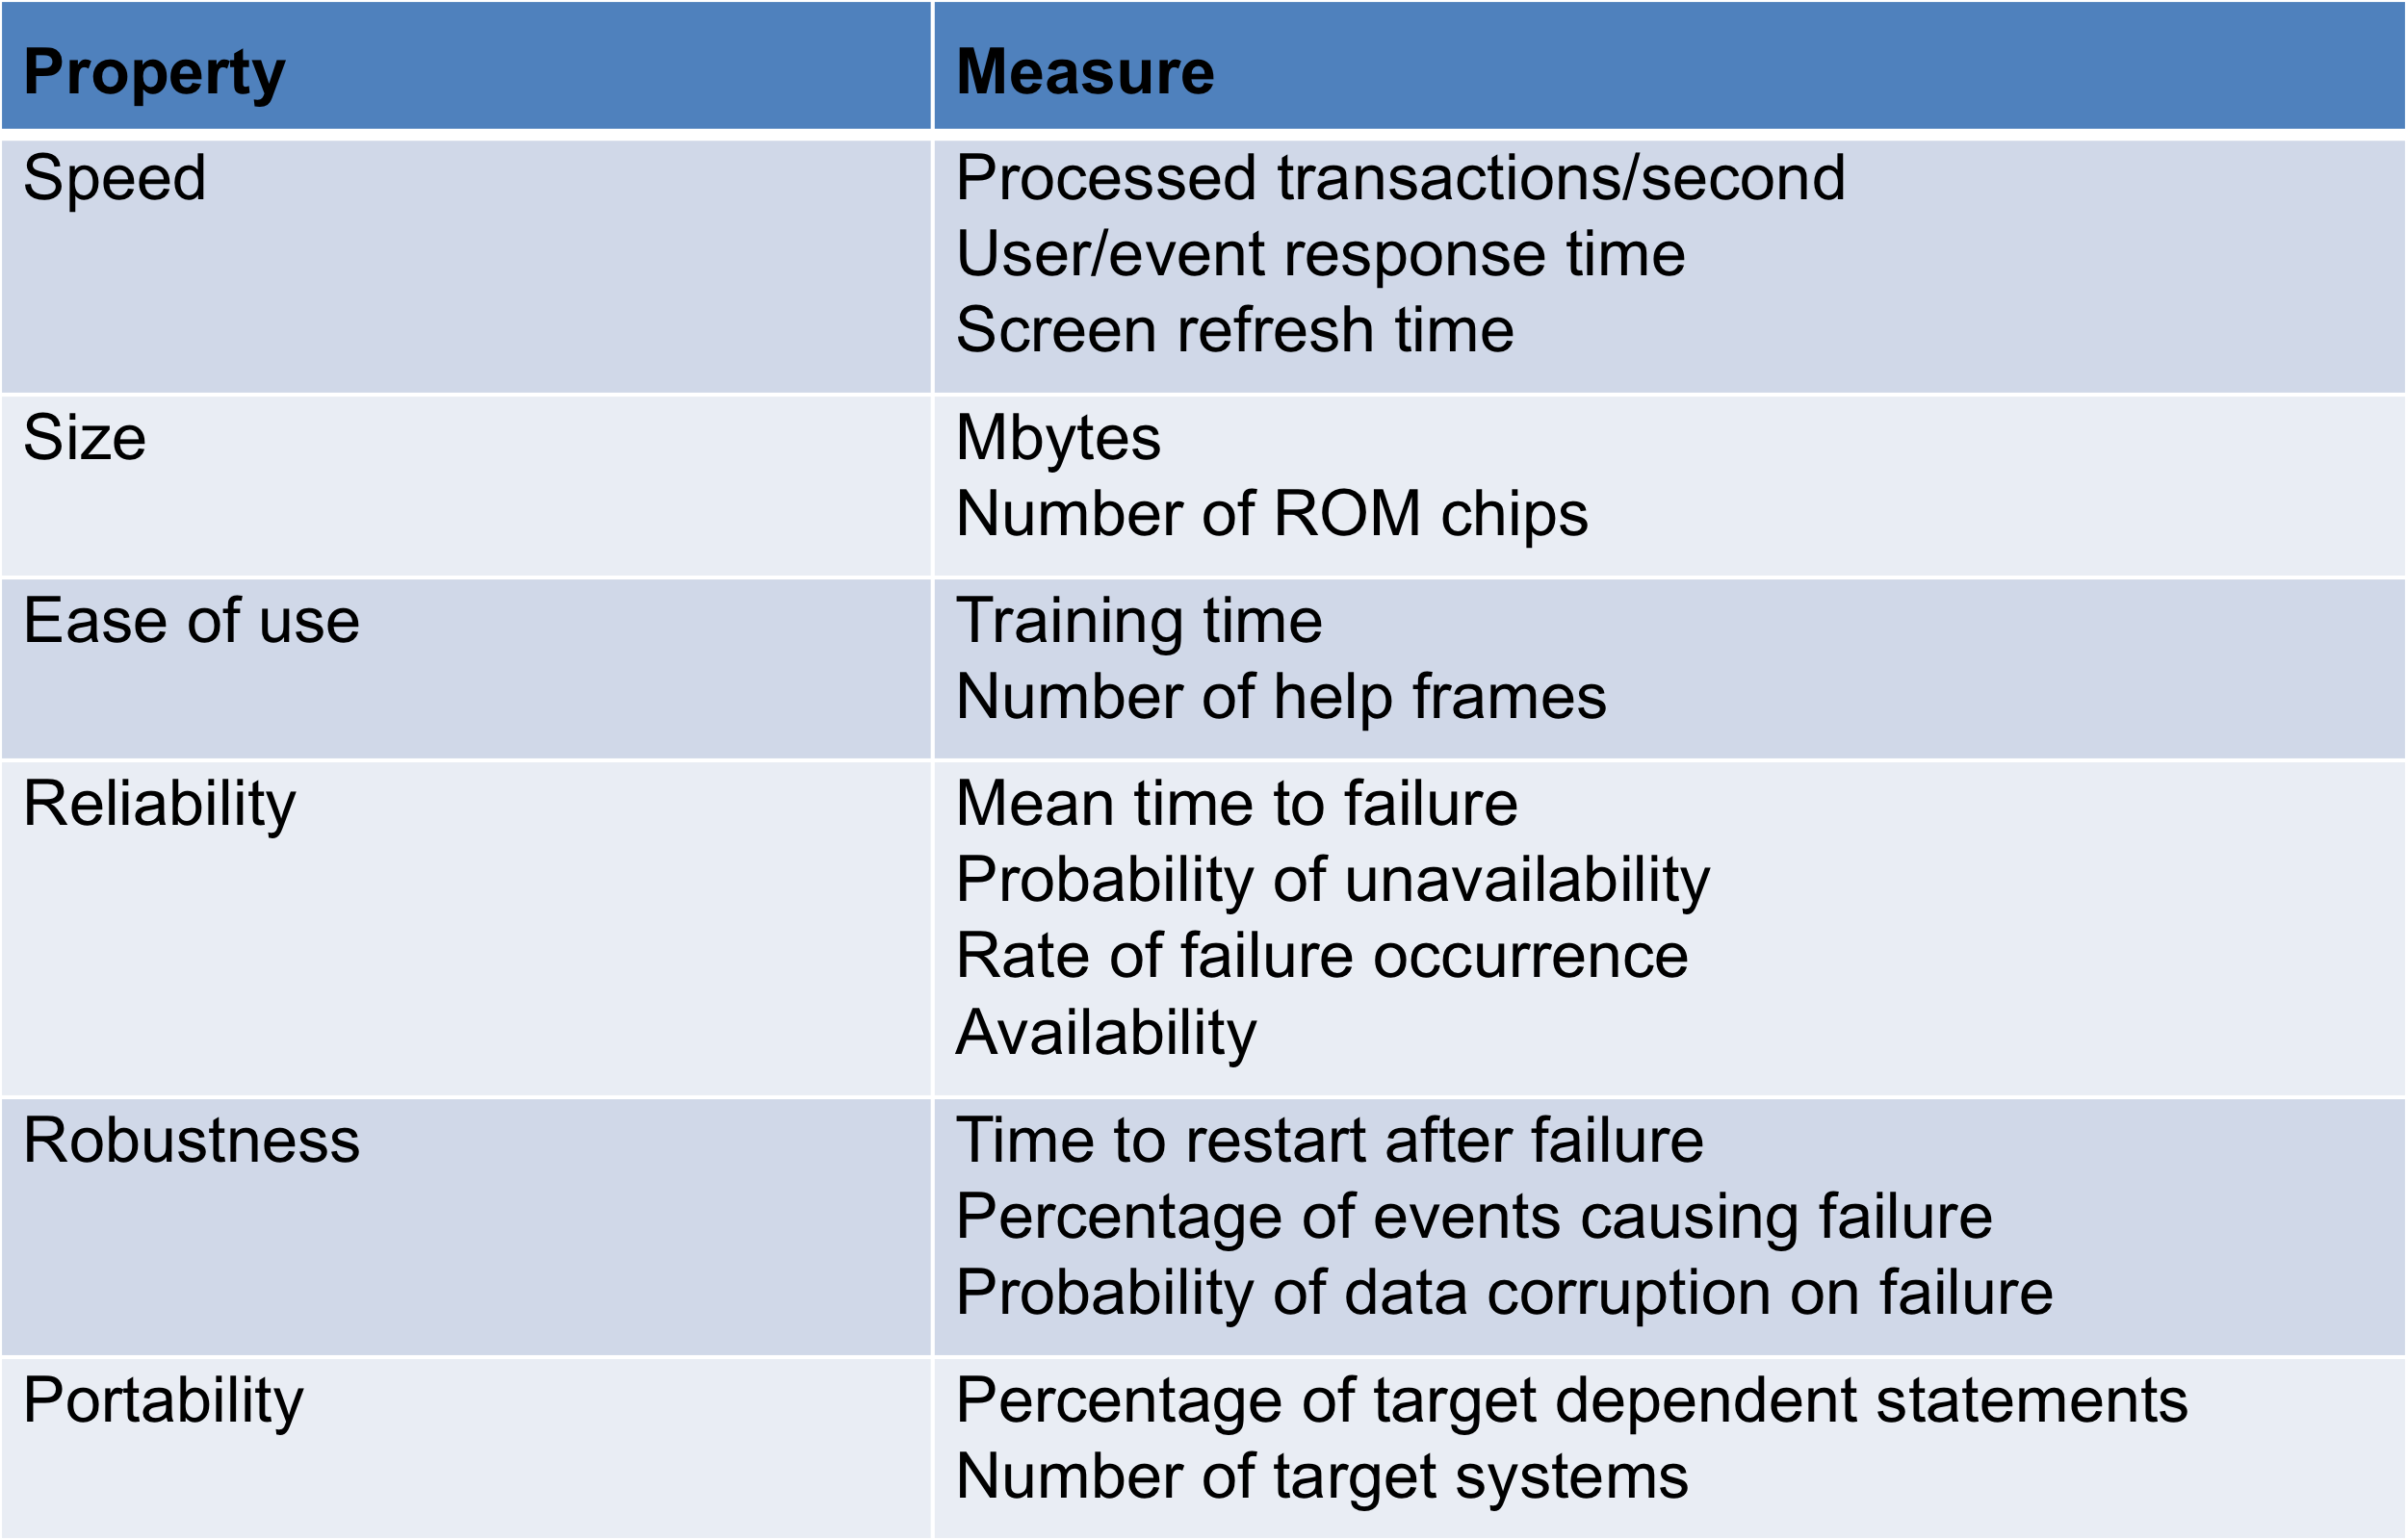

Domain Requirements:

1. The system’s operational domain imposes requirements on the system.
   1. For example, a train control system has to take into account the braking characteristics in different weather conditions.
2. Domain requirements be new functional requirements, constraints on existing requirements or define specific computations.
3. If domain requirements are not satisfied, the system may be unworkable.

Train Protection System:

1. This is a domain requirement for a train protection system:
2. The deceleration of the train shall be computed as:
   1. Dtrain = Dcontrol + Dgradient
   2. where Dgradient is 9.81ms2 \* compensated gradient/alpha and where the values of 9.81ms2 /alpha are known for different types of train.
3. It is difficult for a non-specialist to understand the implications of this and how it interacts with other requirements.

Domain Requirements Problems:

1. Understandability
   1. Requirements are expressed in the language of the application domain;
   2. This is often not understood by software engineers developing the system.
2. Implicitness
   1. Domain specialists understand the area so well that they do not think of making the domain requirements explicit.

Key Points:

1. Requirements for a software system set out what the system should do and define constraints on its operation and implementation.
2. Functional requirements are statements of the services that the system must provide or are descriptions of how some computations must be carried out.
3. Non-functional requirements often constrain the system being developed and the development process being used.
4. They often relate to the emergent properties of the system and therefore apply to the system as a whole.

The Software Requirements Document:

1. The software requirements document is the official statement of what is required of the system developers.
2. Should include both a definition of user requirements and a specification of the system requirements.
3. It is NOT a design document. As far as possible, it should set of WHAT the system should do rather than HOW it should do it.

Agile Methods and Requirements:

1. Many agile methods argue that producing a requirements document is a waste of time as requirements change so quickly.
2. The document is therefore always out of date.
3. Methods such as XP use incremental requirements engineering and express requirements as ‘user stories’ (discussed in Chapter 3).
4. This is practical for business systems but problematic for systems that require a lot of pre-delivery analysis (e.g. critical systems) or systems developed by several teams

Users of a Requirements Document:

4.6 ReqDocUsers.eps

Requirements Document Variability:

1. Information in requirements document depends on type of system and the approach to development used.
2. Systems developed incrementally will, typically, have less detail in the requirements document.
3. Requirements documents standards have been designed e.g. IEEE standard. These are mostly applicable to the requirements for large systems engineering projects.

The Structure of a Requirements Document:

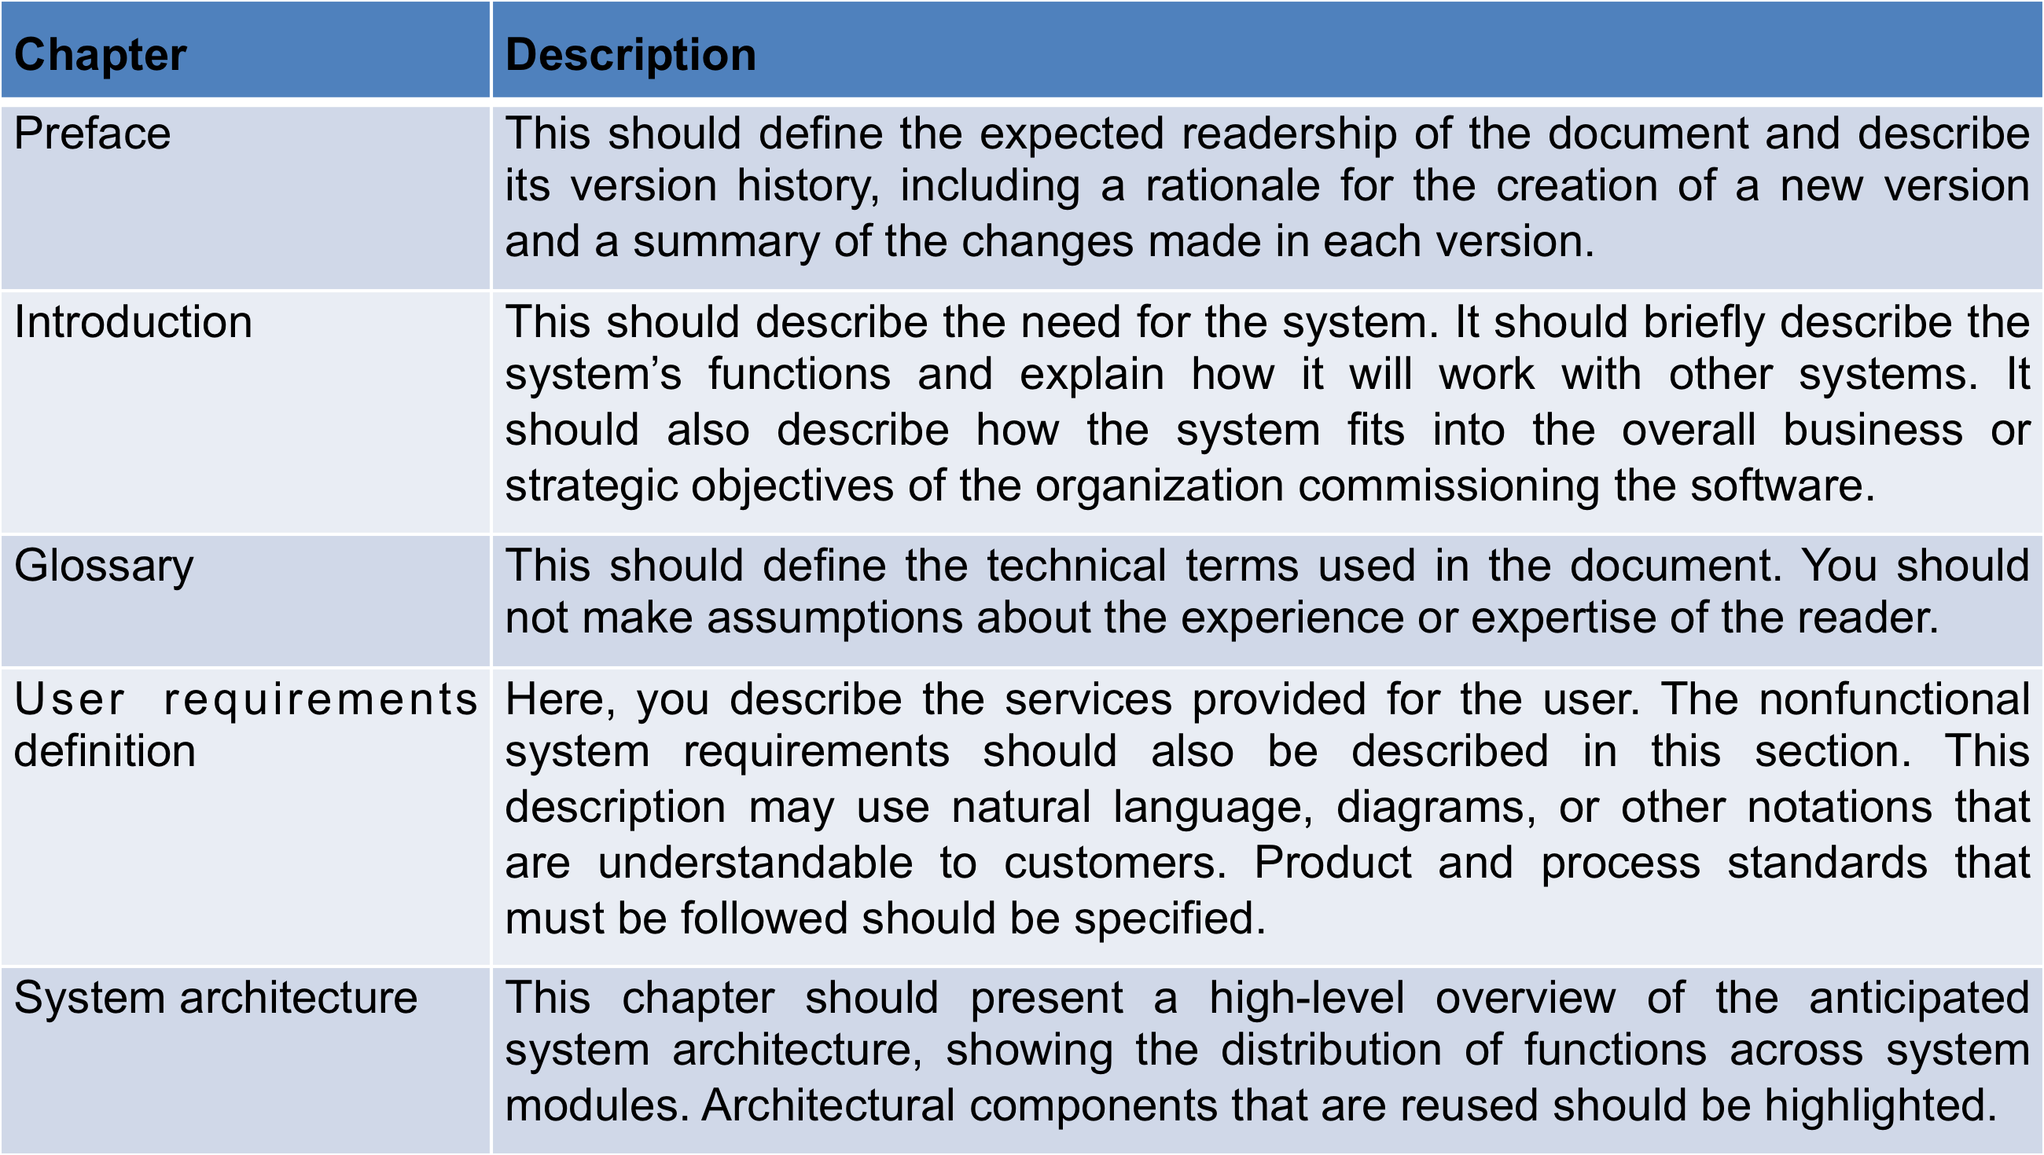

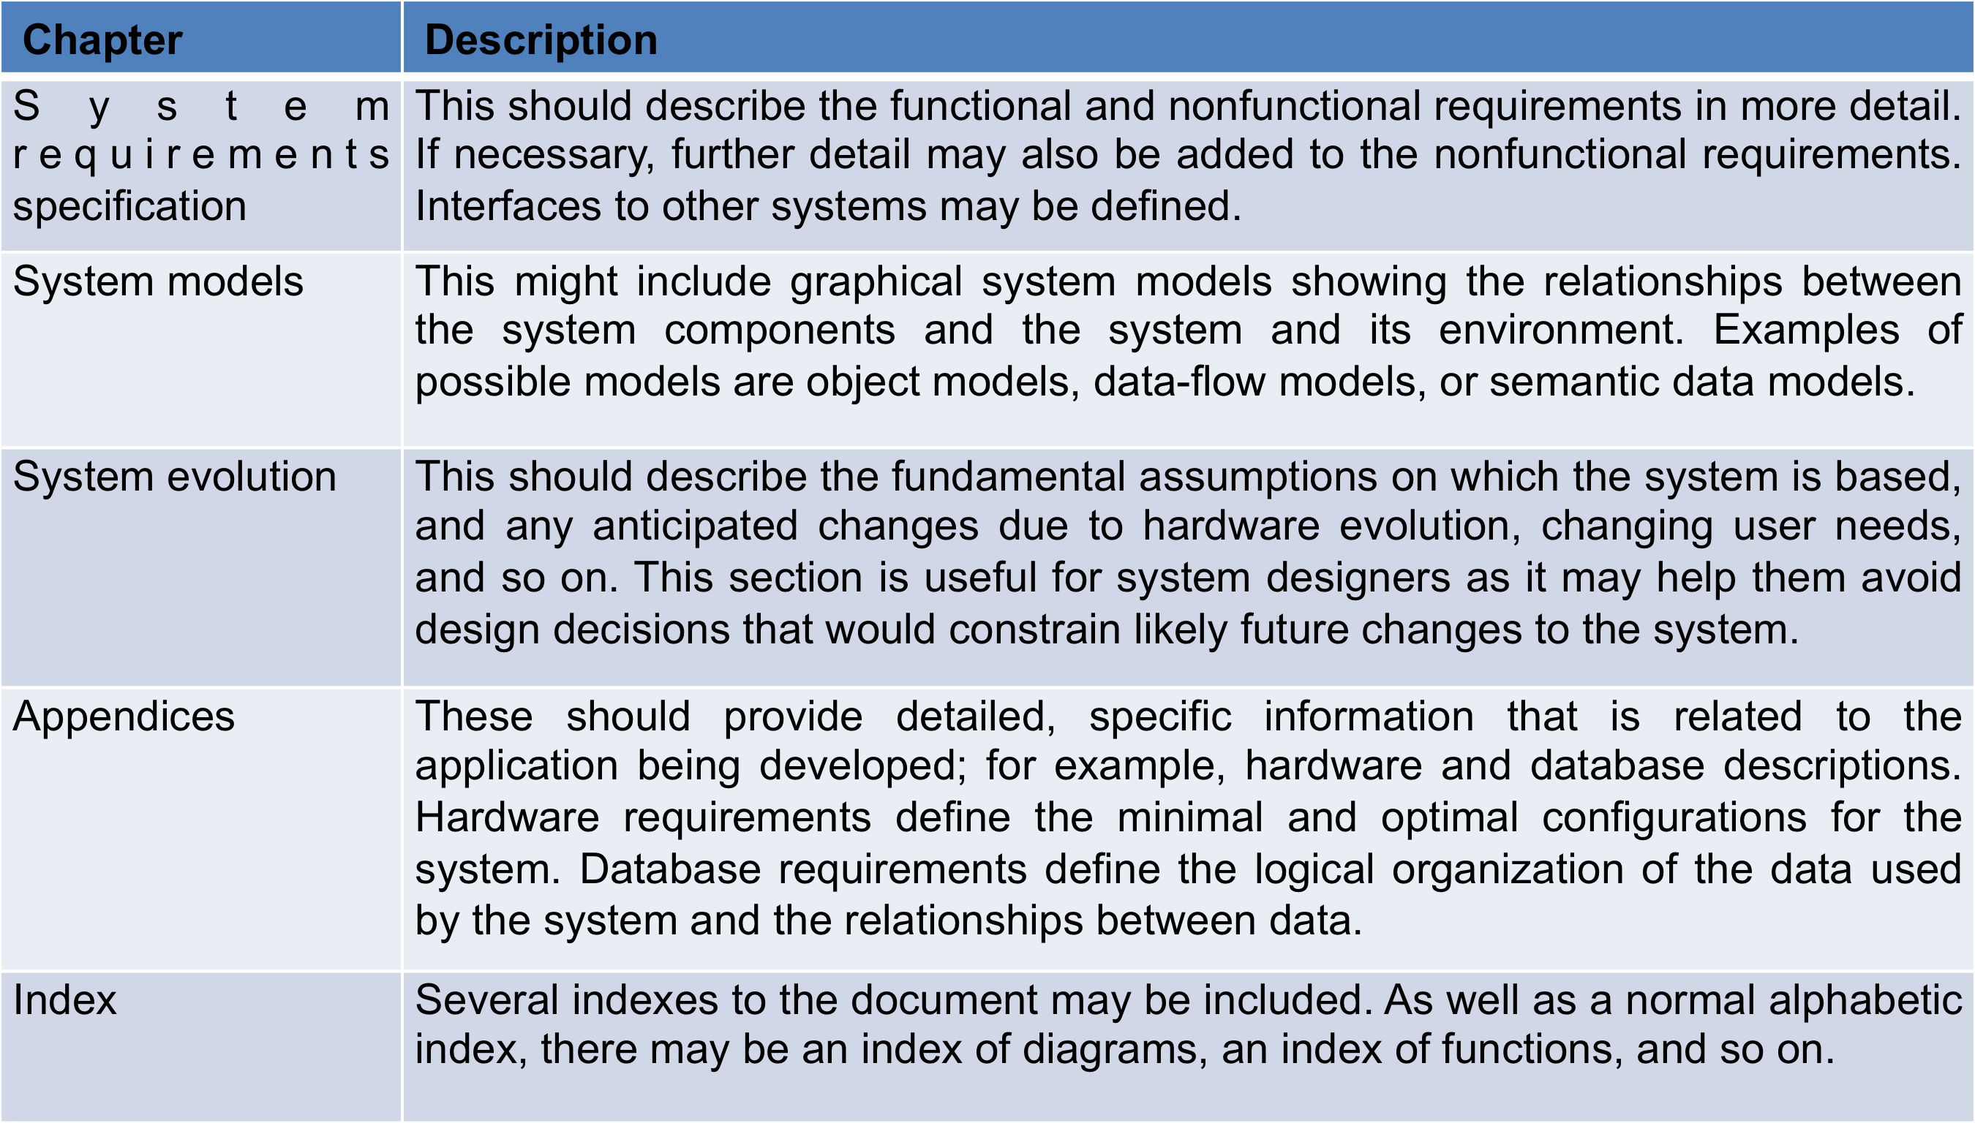

Requirements Specification:

1. The process of writing don the user and system requirements in a requirements document.
2. User requirements have to be understandable by end-users and customers who do not have a technical background.
3. System requirements are more detailed requirements and may include more technical information.
4. The requirements may be part of a contract for the system development
   1. It is therefore important that these are as complete as possible.

Ways of Writing a System Requirements Specification:

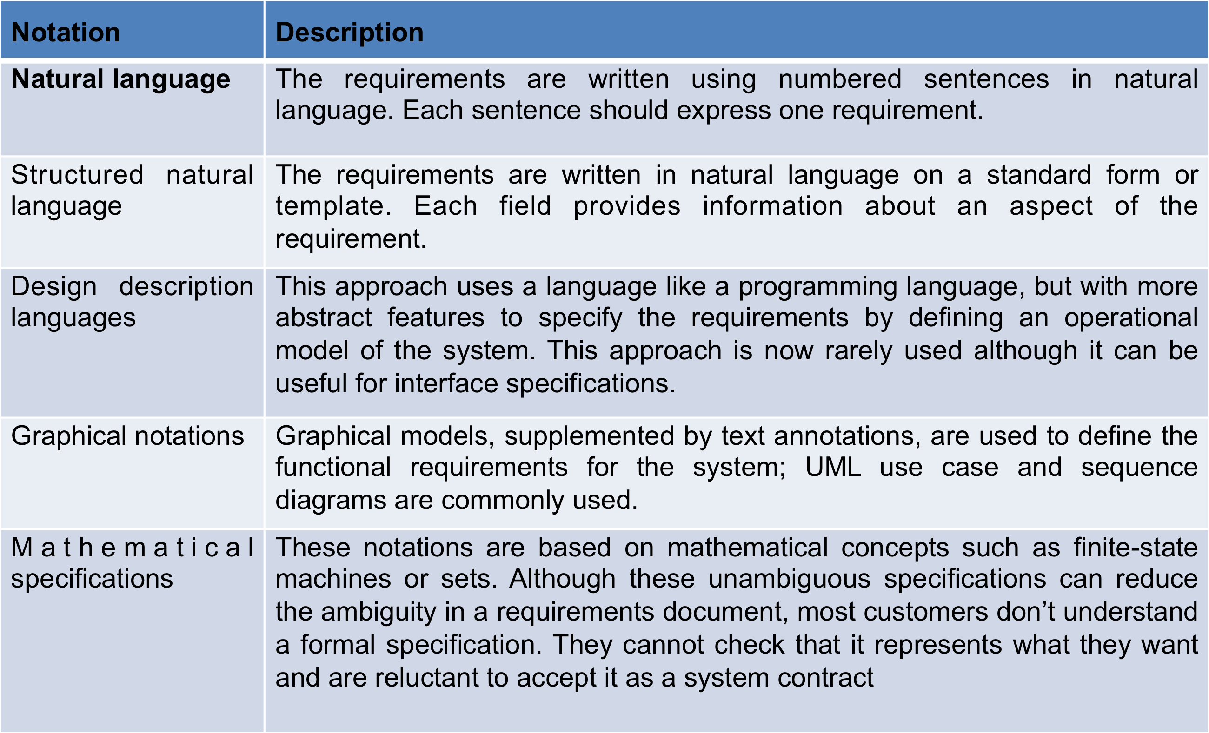

Requirements and Design:

1. In principle, requirements should state what the system should do and the design should describe how it does this.
2. In practice, requirements and design are inseparable
   1. A system architecture may be designed to structure the requirements;
   2. The system may inter-operate with other systems that generate design requirements;
   3. The use of a specific architecture to satisfy non-functional requirements may be a domain requirement.
   4. This may be the consequence of a regulatory requirement.

Natural Language Specification:

1. Requirements are written as natural language sentences supplemented by diagrams and tables.
2. Used for writing requirements because it is expressive, intuitive and universal. This means that the requirements can be understood by users and customers.

Guidelines for Writing Requirements:

1. Invent a standard format and use it for all requirements.
2. Use language in a consistent way. Use shall for mandatory requirements, should for desirable requirements.
3. Use text highlighting to identify key parts of the requirement.
4. Avoid the use of computer jargon.
5. Include an explanation (rationale) of why a requirement is necessary.

Problems with Natural Language:

1. Lack of clarity
   1. Precision is difficult without making the document difficult to read.
2. Requirements confusion
   1. Functional and non-functional requirements tend to be mixed-up.
3. Requirements amalgamation
   1. Several different requirements may be expressed together.

Structured Specifications:

1. An approach to writing requirements where the freedom of the requirements writer is limited and requirements are written in a standard way.
2. This works well for some types of requirements e.g. requirements for embedded control system but is sometimes too rigid for writing business system requirements.

Form-based Specifications:

1. Definition of the function or entity.
2. Description of inputs and where they come from.
3. Description of outputs and where they go to.
4. Information about the information needed for the computation and other entities used.
5. Description of the action to be taken.
6. Pre and post conditions (if appropriate).
7. The side effects (if any) of the function.

Tubular Specification:

1. Used to supplement natural language.
2. Particularly useful when you have to define a number of possible alternative courses of action.
3. For example, the insulin pump systems bases its computations on the rate of change of blood sugar level and the tabular specification explains how to calculate the insulin requirement for different scenarios.

Requirements Engineering Processes:

1. The processes used for RE vary widely depending on the application domain, the people involved and the organisation developing the requirements.
2. However, there are a number of generic activities common to all processes
   1. Requirements elicitation;
   2. Requirements analysis;
   3. Requirements validation;
   4. Requirements management.
3. In practice, RE is an iterative activity in which these processes are interleaved.

Requirements Elicitation and Analysis:

1. Sometimes called requirements elicitation or requirements discovery.
2. Involves technical staff working with customers to find out about the application domain, the services that the system should provide and the system’s operational constraints.
3. May involve end-users, managers, engineers involved in maintenance, domain experts, trade unions, etc. These are called *stakeholders.*

Problems with Requirements Analysis:

1. Stakeholders don’t know what they really want.
2. Stakeholders express requirements in their own terms.
3. Different stakeholders may have conflicting requirements.
4. Organisational and political factors may influence the system requirements.
5. The requirements change during the analysis process. New stakeholders may emerge and the business environment may change.

Requirements Elicitation and Analysis:

1. Software engineers work with a range of system stakeholders to find out about the application domain, the services that the system should provide, the required system performance, hardware constraints, other systems, etc.
2. Stages include:
   1. Requirements discovery,
   2. Requirements classification and organization,
   3. Requirements prioritization and negotiation,
   4. Requirements specification.

The Requirements Elicitation and Analysis Process:

4.13 RequirementsElicitation.eps

Process Activities:

1. Requirements discovery
   1. Interacting with stakeholders to discover their requirements. Domain requirements are also discovered at this stage.
2. Requirements classification and organisation
   1. Groups related requirements and organises them into coherent clusters.
3. Prioritisation and negotiation
   1. Prioritising requirements and resolving requirements conflicts.
4. Requirements specification
   1. Requirements are documented and input into the next round of the spiral.

Problems of Requirements Elicitation:

1. Stakeholders don’t know what they really want.
2. Stakeholders express requirements in their own terms.
3. Different stakeholders may have conflicting requirements.
4. Organisational and political factors may influence the system requirements.
5. The requirements change during the analysis process. New stakeholders may emerge and the business environment change.

Key Points:

1. The software requirements document is an agreed statement of the system requirements. It should be organized so that both system customers and software developers can use it.
2. The requirements engineering process is an iterative process including requirements elicitation, specification and validation.
3. Requirements elicitation and analysis is an iterative process that can be represented as a spiral of activities – requirements discovery, requirements classification and organization, requirements negotiation and requirements documentation.

Requirements Discovery:

1. The process of gathering information about the required and existing systems and distilling the user and system requirements from this information.
2. Interaction is with system stakeholders from managers to external regulators.
3. Systems normally have a range of stakeholders.

Stakeholder in the MHC-PMS:

1. Patientswhose information is recorded in the system.
2. Doctorswho are responsible for assessing and treating patients.
3. Nurses who coordinate the consultations with doctors and administer some treatments.
4. Medical receptionistswho manage patients’ appointments.
5. IT staff who are responsible for installing and maintaining the system.
6. A medical ethics manager who must ensure that the system meets current ethical guidelines for patient care.
7. Health care managerswho obtain management information from the system.
8. Medical records staffwho are responsible for ensuring that system information can be maintained and preserved, and that record keeping procedures have been properly implemented.

Interviewing:

1. Formal or informal interviews with stakeholders are part of most RE processes.
2. Types of interview
   1. Closed interviews based on pre-determined list of questions
   2. Open interviews where various issues are explored with stakeholders.
3. Effective interviewing
   1. Be open-minded, avoid pre-conceived ideas about the requirements and are willing to listen to stakeholders.
   2. Prompt the interviewee to get discussions going using a springboard question, a requirements proposal, or by working together on a prototype system.

Interviews in Practice:

1. Normally a mix of closed and open-ended interviewing.
2. Interviews are good for getting an overall understanding of what stakeholders do and how they might interact with the system.
3. Interviews are not good for understanding domain requirements
   1. Requirements engineers cannot understand specific domain terminology;
   2. Some domain knowledge is so familiar that people find it hard to articulate or think that it isn’t worth articulating.

Scenarios:

1. Scenarios are real-life examples of how a system can be used.
2. They should include
   1. A description of the starting situation;
   2. A description of the normal flow of events;
   3. A description of what can go wrong;
   4. Information about other concurrent activities;
   5. A description of the state when the scenario finishes.

Use Cases:

1. Use-cases are a scenario based technique in the UML which identify the actors in an interaction and which describe the interaction itself.
2. A set of use cases should describe all possible interactions with the system.
3. High-level graphical model supplemented by more detailed tabular description (see Chapter 5).
4. Sequence diagrams may be used to add detail to use-cases by showing the sequence of event processing in the system.

Use Cases for the MHC-PMS

4.15 UseCases.eps

Ethnography:

1. A social scientist spends a considerable time observing and analysing how people actually work.
2. People do not have to explain or articulate their work.
3. Social and organisational factors of importance may be observed.
4. Ethnographic studies have shown that work is usually richer and more complex than suggested by simple system models.

Scope of Ethnography:

1. Requirements that are derived from the way that people actually work rather than the way I which process definitions suggest that they ought to work.
2. Requirements that are derived from cooperation and awareness of other people’s activities.
   1. Awareness of what other people are doing leads to changes in the ways in which we do things.
3. Ethnography is effective for understanding existing processes but cannot identify new features that should be added to a system.

Focused Ethnography:

1. Developed in a project studying the air traffic control process
2. Combines ethnography with prototyping
3. Prototype development results in unanswered questions which focus the ethnographic analysis.
4. The problem with ethnography is that it studies existing practices which may have some historical basis which is no longer relevant.

Ethnography and prototyping for requirements analysis:

4.16 Ethno-prototyping.eps

Requirements Validation:

1. Concerned with demonstrating that the requirements define the system that the customer really wants.
2. Requirements error costs are high so validation is very important
3. Fixing a requirements error after delivery may cost up to 100 times the cost of fixing an implementation error

Requirements Checking:

1. Validity. Does the system provide the functions which best support the customer’s needs?
2. Consistency. Are there any requirements conflicts?
3. Completeness. Are all functions required by the customer included?
4. Realism. Can the requirements be implemented given available budget and technology
5. Verifiability. Can the requirements be checked?

Requirements Validation Techniques:

1. Requirements reviews
   1. Systematic manual analysis of the requirements.
2. Prototyping
   1. Using an executable model of the system to check requirements. Covered in Chapter 2.
3. Test-case generation
   1. Developing tests for requirements to check testability.

Review Checks:

1. Verifiability
   1. Is the requirement realistically testable?
2. Comprehensibility
   1. Is the requirement properly understood?
3. Traceability
   1. Is the origin of the requirement clearly stated?
4. Adaptability
   1. Can the requirement be changed without a large impact on other requirements?

Requirements Management:

1. Requirements management is the process of managing changing requirements during the requirements engineering process and system development.
2. New requirements emerge as a system is being developed and after it has gone into use.
3. You need to keep track of individual requirements and maintain links between dependent requirements so that you can assess the impact of requirements changes. You need to establish a formal process for making change proposals and linking these to system requirements.

Changing Requirements:

1. The business and technical environment of the system always changes after installation.
   1. New hardware may be introduced, it may be necessary to interface the system with other systems, business priorities may change (with consequent changes in the system support required), and new legislation and regulations may be introduced that the system must necessarily abide by.
2. The people who pay for a system and the users of that system are rarely the same people.
   1. System customers impose requirements because of organizational and budgetary constraints. These may conflict with end-user requirements and, after delivery, new features may have to be added for user support if the system is to meet its goals.
3. Large systems usually have a diverse user community, with many users having different requirements and priorities that may be conflicting or contradictory.
4. The final system requirements are inevitably a compromise between them and, with experience, it is often discovered that the balance of support given to different users has to be changed.

Requirements Evolution:

4.17 ReqEvolution.eps

Requirements Management Planning:

1. Establishes the level of requirements management detail that is required.
2. Requirements management decisions:
   1. *Requirements identification* Each requirement must be uniquely identified so that it can be cross-referenced with other requirements.
   2. *A change management process* This is the set of activities that assess the impact and cost of changes. I discuss this process in more detail in the following section.
   3. *Traceability policies* These policies define the relationships between each requirement and between the requirements and the system design that should be recorded.
3. *Tool support* Tools that may be used range from specialist requirements management systems to spreadsheets and simple database systems

Requirements Change Management:

1. Deciding if a requirements change should be accepted
   1. *Problem analysis and change specification*
      1. During this stage, the problem or the change proposal is analyzed to check that it is valid. This analysis is fed back to the change requestor who may respond with a more specific requirements change proposal, or decide to withdraw the request.
   2. *Change analysis and costing*
      1. The effect of the proposed change is assessed using traceability information and general knowledge of the system requirements. Once this analysis is completed, a decision is made whether or not to proceed with the requirements change.
   3. Change implementation
      1. The requirements document and, where necessary, the system design and implementation, are modified. Ideally, the document should be organized so that changes can be easily implemented.

Requirements Change Management:

4.18 ReqChangeMan.eps

Key Points:

1. You can use a range of techniques for requirements elicitation including interviews, scenarios, use-cases and ethnography.
2. Requirements validation is the process of checking the requirements for validity, consistency, completeness, realism and verifiability.
3. Business, organizational and technical changes inevitably lead to changes to the requirements for a software system. Requirements management is the process of managing and controlling these changes.